2nd Gymnasium of Paianias
Katerina Gialoumi, Maria Panagiotopoulou, Orsalia Polykala, Yanni Sema

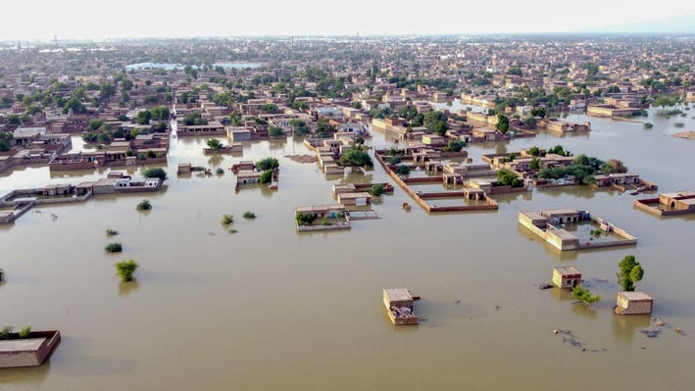

floods: | THE FLOOD OF THESSALIA

CONTENTS:

- WHAT’S A FLOOD?..................................................................... p.2
- HOW ARE FLOODS FORM?......................................................... p.2
- WHAT ARE THE CONCEQUENCES?..............................................p.2
- WHAT CAN WE DO TO LIMIT THEM?..........................................p.3
- FLOOD RISK AGGRAVATING FACTORS........................................ p.3
- STEPS OF A COMPREHENSIVE FLOOD PROTECTION STUDY........p.3
- THE FLOOD OF THESALIA............................................................ p.4
- UGC PRESS RELEASE ON THE THESSALIA FLOOD.........................p.5
- REFERENCES................................................................................ p.6

What’s a flood?
Floods are the second most widespread natural disaster on earth after wildfires and are among earth’s most destructive natural hazards.
How are floods form?
A flood occurs when an overflow of water inundates land. It can be caused due to excessive rainfall, rapid snowmelt, a storm or due to a raptured dam. Most floods take hours or even days to develop, but there are others that generate extremely quickly. This kind of floods is called a flash flood and it is tremendously dangerous because it can catch people unaware.
Although typically floods are a natural phenomenon, humans and the damage they cause to the environment increase the possibility of flooding. It goes without saying that the risk of flooding is perpetually increasing due to climate change.
What are the consequences?
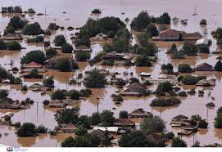
The consequences of flooding have detrimental effects not only on the environment but on human lives too. For instance it can damage vegetation and crops because of pollutants that are carried by flood water. These pollutants have a negative impact on water quality and they have an adverse effect on both flora and fauna. Moreover, floodwaters can cause structural damage to roads making commuting difficult or even impossible. Floods damage vital infrastructure and prevent access to essential public services like hospitals. Furthermore, floods inundate properties and businesses. They can destroy peoples’ belongings or even threaten their lives.

What can we do to limit them?
We firmly believe that it is our duty as conscientious citizens of the world to try our best to prevent flooding. We should clean sewers more often, install drainage systems, repair drain pipes and take measures to keep storm drains free from blockages.
Last but not least we should help limit climate change which is one of the main reasons of flooding. We can make a difference if we use our recourses more wisely in order to protect the environment. A fruitful metamorphosis of the existing situation, where human beings keep polluting the environment uncontrollably could be done if we become more conscientious citizens. This way we can lay the foundations for a safer future.
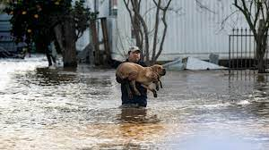
Flood risk aggravation factors
- Reduction of forest areas
- Serious problem of soil erosion due to deforestation
- Reduction of supply of underground aquifers
- Urbanization- Loss of human life
Steps of a comprehensive flood protection study
- Recording of streams and more general study area with GIS.
- Rainfall network recording with GIS.
- Study of rain curves.
- Hydrological study for main streams (watersheds, peak flows and flood volume for various reset periods).
- Assessment of danger zones (inundation areas of equal flood risk).
- Hydraulic study of adequacy of sections and level – identification of critical areas.
- Similarly for network of rain.
- Proposals for constructive and non-constructive flood protection measures.
- Program for prioritizing projects and flood prevention measures.

The flood of Thessalia
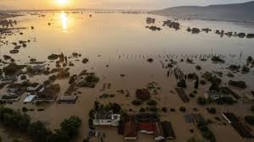
On September 5, 2023 the flood in Thessalia Area, killed at least one person. On the same day, the village of Zagora received 1,092 millimeters of rain, 55 times more than the country's average rainfall for the same month. Portaria also recorded a new rainfall record of 884 mm. Further rainfall could not be measured because the weather station subsequently failed. On September 6, the Krafsidonas river, which rises at Pelion, overflowed its banks in Volos and destroyed a bridge and a nursing home, while dragging cars, trees and other debris along its path.
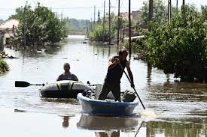
On September 7, the main motorway between Athens and Thessaloniki was closed and train services between the two cities were suspended. In Thessalia, over 800 people had to be rescued amidst collapsed buildings and bridges and submerged villages. In Larissa, after the rains ended on September 8, water continued to rise as the Pineios river overflowed its banks to reach a level of 9.5 metres, compared to the normal level of 4 m. In the Vale of Tempe, the water level rose to about 18 meters, reaching the level of a suspension bridge.
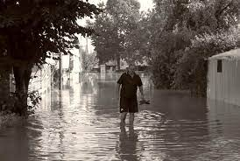
One man died in Volos when a wall collapsed on him, and in the nearby Pelion area the body of an old lady was discovered on 6 September while four people were reported missing. A lot of villages in and around the Pelion Mountain suffered huge damage.

UGC press release on the Thessalia flood
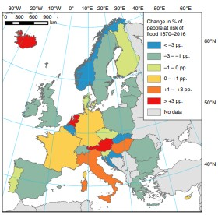
The Union of Greek Chemists, which is the scientific body of Greek chemists and its Environment Department, which are responsible for matters concerning the Environment and its protection, considers that among the most important effects on the environment, which floods have, is that on water quality. When floodwaters wash over the land, they carry with them various pollutants such as fertilizers, chemicals from factories and debris such as plastics and other waste. These pollutants end up being carried into river systems causing damage to aquatic life, but also to the water used for the water supply of these areas. The result of this is the possibly increased acidity of the water as well as the growth of pathogenic microbes and viruses. In its wake the already contaminated water with the increased concentrations of pesticides, and other pollutants is mixed with human and animal waste, decaying animal carcasses, agricultural and industrial wastes, thus carrying significant amounts of toxic substances such as heavy metals and organic pollutants.

Trends in flood exposure. Percent of the population exposed to the 100-year river and coastal flood in Europe in percentage points, to the 100-year flood (either river or coastal) in each country (1870–2016).

Source of data: HANZE database

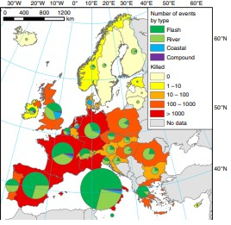

Flood occurrences and fatalities. Total number of flood events and fatalities between 1870 and 2016, by country.

Source of data: HANZE database

References:

https://en.wikipedia.org/wiki/Storm_Daniel
https://www.nature.com/ncomms/
https://www.eex.gr/news/deltia-tupou
http://edu.chi.civil.ntua.gr/site-LESSONS/HTML_PLIMIRES/PERIEXOMENO/Prosthetes_simioseis_GREECE.htm

